

GUIDELINE
Digital Battery Passport:
Use Case Guideline of the Asset Administration Shell
February 2026
Imprint

Publisher
Industrial Digital Twin Association
Lyoner Strasse 18
60528 Frankfurt am Main
Germany
https://www.industrialdigitaltwin.org/

Version history

Date | Version/Revision | CHANGES made
13.02.2026 | 1.0 | Release of the Guideline by IDTA, Catena-X and the BatteryPass Consortium.

Contents
1 General 5
1.1 About this document 5
1.2 Scope of the Use Case 5
1.3 Relevant standards and projects for the Use Case 6
1.4 Scenarios, requirements and design decisions 6
1.4.1 Scenarios 6
1.4.2 Design Decisions 7
2 Overview of Digital Battery Passport as AAS 9
2.1 Overview 9
2.2 Digital Nameplate for the Digital Battery Passport 10
2.3 Handover Documentation for the Digital Battery Passport 10
2.4 Carbon Footprint for the Digital Battery Passport 11
2.5 Technical Data for the Digital Battery Passport 12
2.6 Product Condition for the Digital Battery Passport 13
2.7 Material Composition for the Digital Battery Passport 14
2.8 Circularity for the Digital Battery Passport 15
Annex A. Explanations on used table formats 17
1. General 17
2. Tables on Submodels and SubmodelElements 17
Bibliography 18

Figures
Figure 1: Conceptional overview of the design of the Digital Battery Passport based on the AAS 8
Figure 2: AAS example of a Digital Battery Passport with all submodels (screenshot from AASX Explorer) 9
Figure 3: Sample instance of the BatteryNameplate submodel 9
Figure 4: Overview submodel template Digital Battery Nameplate 10
Figure 5: Overview submodel template Handover Documentation 11
Figure 6: Overview submodel template Carbon Footprint 11
Figure 7: Overview submodel template Technical Data 13
Figure 8: Overview submodel template Product Condition 14
Figure 9: Overview submodel template Material Composition 15
Figure 10: Overview submodel template Circularity 16

General

About this document
This document is a use case of a specification series about the Digital Battery Passport. The content was coordinated in the Joint Woking Group "Battery Data Template" with participation of IDTA [7], Catena-X [12], and Battery Pass Consortium [10] members and it is made available in a combined IDTA and Catena-X layout.

Scope of the Use Case
This work focuses on the implementation of the Digital Battery Passport (DBP) using the Asset Administration Shell (AAS), addressing the European Union regulatory requirements ((EU)2023/1542, Article77 and AnnexXIII) for battery sustainability and traceability. According to the new EU Battery Regulation, electric vehicle (EV) batteries and industrial batteries with a capacity above 2kWh will require a mandatory unique Digital Battery Passport (DBP) to be placed on the EU market. This regulation, scheduled to take effect from February 18, 2027, mandates that each battery must be equipped with a QR code linking to its digital passport.
To fulfill the regulatory requirements of the EU Battery Regulation, specific submodels within the AAS framework should be used. These submodels shall capture and manage all mandatory information required by the regulation.
Details of the specifications are covered by different parts:
- Digital Battery Passport - Part 1: Digital Nameplate 1.0 (IDTA-02035-1)
- Digital Battery Passport - Part 2: Handover Documentation 1.0 (IDTA-02035-2)
- Digital Battery Passport - Part 3: Product Carbon Footprint 1.0 (IDTA-02035-3)
- Digital Battery Passport - Part 4: Technical Data 1.0 (IDTA-02035-4)
- Digital Battery Passport - Part 5: Product Condition 1.0 (IDTA-02035-5)
- Digital Battery Passport - Part 6: Material Composition 1.0 (IDTA-02035-6)
- Digital Battery Passport - Part 7: Circularity 1.0 (IDTA-02035-7)

The structure follows the following rationale:
- Part 1 is on instance level (granularity “item”) and contains only static information that does not change over the lifetime of the product for which a DPP needs to be provided (Note: Properties like “batteryStatus” if changed would need a new DPP with a new DPP ID).
- Part 2 and Part 4 as well as Part 6 and 7 are on type level (granularity “model”): the same information holds for all instances of the battery type.
- Part 3 relates to the battery type (granularity “model”) per manufacturing plant: the same information holds for alle instances of the battery type produced at the same facility. The manufacturing plant is defined in Part 1 via the uniqueFacilityIdentifier.
- Part 5 is on instance level (granularity “item”) and contains dynamic data that needs to be updated at defined points in time or intervals during the lifetime of the product with the same DPP ID.
This document contains instructions on how the individual submodels can be used to specify the relevant attributes that meet regular requirements as documented in DIN DKE SPEC 99100 [9].

Relevant standards and projects for the Use Case
This work is a joint work of Industrial Digital Twin Association (IDTA), Catena-X [12], and the Battery Passport consortia project [10]. The basis for compliance with European Union regulatory requirements for batteries, this use case, and the associated submodels meet the requirements for battery passport data attributes in accordance with DIN DKE SPEC 99100 [9].
The process to create the Submodel Templates was carried out in alignment to the “Semantic driven workflow” as described in [1] (https://industrialdigitaltwin.org/wp-content/uploads/2025/06/IDTA_How-to-write-a-SMT-v1.1.pdf). For all Submodel Templates semantic definitions aspect models conformant to SAMM [2] are provided to be compliant to IDTA as well as to Catena-X modelling processes. Existing Submodel Templates and existing aspect models were reused when available and appropriate. For the documentation the “Model based workflow with single source AsciiDoc” was applied, this means main part of the documentation are generated from source code.
The Submodel Template Specifications including the .aasx files etc. will be pulished here: submodel-templates/published at main · admin-shell-io/submodel-templates
The .ttl file of the Aspect Models for these Submodel Templates including generated files will be published here: admin-shell-io/smt-semantic-models: This repository is for aspect models that are used as semantic definition in Submodel Templates. For review the files are here: admin-shell-io/smt-semantic-models at smt-xg/BatteryPass_Working.

Scenarios, requirements and design decisions

Scenarios

Basic Information about Battery Condition
A potential electric vehicle buyer at a used car dealership wants to check the battery condition of a 2025 electric vehicle. They locate the QR code on the battery housing and scan it using their smartphone. Through the Digital Battery Passport interface and the provided AAS, they can access:
- Battery Model: XYZ-Battery Model
- Initial Capacity: 82 kWh
- Current Capacity: 77.1 kWh (94% of original capacity)
- Manufacturing Date: March 2025
This information helps the buyer make an informed decision about the vehicle's value and remaining battery life, providing transparency about the battery's current state and performance capabilities.

Recycling Batteries
A recycling facility receives an EV battery for evaluation of potential second life applications (e.g., Home Energy Storage, Industrial Buffer Storage). The recycling technician scans the QR code to access essential information through the Digital Battery Passport as AAS:
Battery assessment data such as:
- Initial/Current Capacity: 111.5 kWh / 89.2 kWh
- Usage History:
  - Charging Cycles: 1124
  - Temperature Extremes: Max 42°C, Min -8°C
  - Deep Discharge Events: 1
- Module Health Status: All 10 modules functional
- Safety Instructions: Handling protocols and dismantling guide
Based on this data, the recycler can quickly determine if the battery is suitable for refurbishment and second life use, or if it should be directed to material recycling, ensuring optimal resource utilization.

Design Decisions
The Digital Battery Passport (DBP) contains 7 different Submodels where three are derived from existing IDTA Submodel Template specifications, namely Digital Nameplate for Industrial Equiqment 3.0 (IDTA-02006), Handover Documentation 2.0 (IDTA-02004), and Product Carbon Footprint 1.0 (IDTA-02023):
- Digital Battery Passport - Part 1: Digital Nameplate 1.0 (IDTA-02035-1)
- Digital Battery Passport - Part 2: Handover Documentation 1.0 (IDTA-02035-2)
- Digital Battery Passport - Part 3: Product Carbon Footprint 1.0 (IDTA-02035-3)
These Submodels will provide semanticIds as specified in the orign specification documents (mainly based on ECLASS, IEC CDD and IDTA).
A new Submodel will be created as extenstion of Generic Technical Data 2.0 Submodel Template (IDTA- 02003-2-0):
- Digital Battery Passport - Part 4: Technical Data 1.0 (IDTA-02035-4)
The semanticIds are based on ECLASS, otherwise the corresponding aspect model semantics are used.
The remaining three Submodels are coming from the “BatteryPass made with Germany” project.
- Digital Battery Passport - Part 5: Product Condition 1.0 (IDTA-02035-5)
- Digital Battery Passport - Part 6: Material Compostion 1.0 (IDTA-02035-6)
- Digital Battery Passport - Part 7: Circularity 1.0 (IDTA-02035-7)
The used semanticIds are based on the corresponding aspect models.
All relevant documents (e.g. PDFs) for the DBP are manged by the Digital Battery Passport - Part 2: Handover Documentation 1.0. At specific locations within the submodels in
- Digital Battery Passport - Part 1: Digital Nameplate 1.0 (IDTA-02035-1)
- Digital Battery Passport - Part 3: Product Carbon Footprint 1.0 (IDTA-02035-3)
- Digital Battery Passport - Part 7: Circularity 1.0 (IDTA-02035-7)
A document identifier is provided, which must be matched with a document identifier in the “Handover Documentation” submodel in order to obtain the complete details of the document (e.g., document title, path to the PDF, etc).
The following figure gives an overview, how the the provides submodels and aspect models relates to eachother and should converge to a AAS representation that can be used for the Digital Battery Passport.
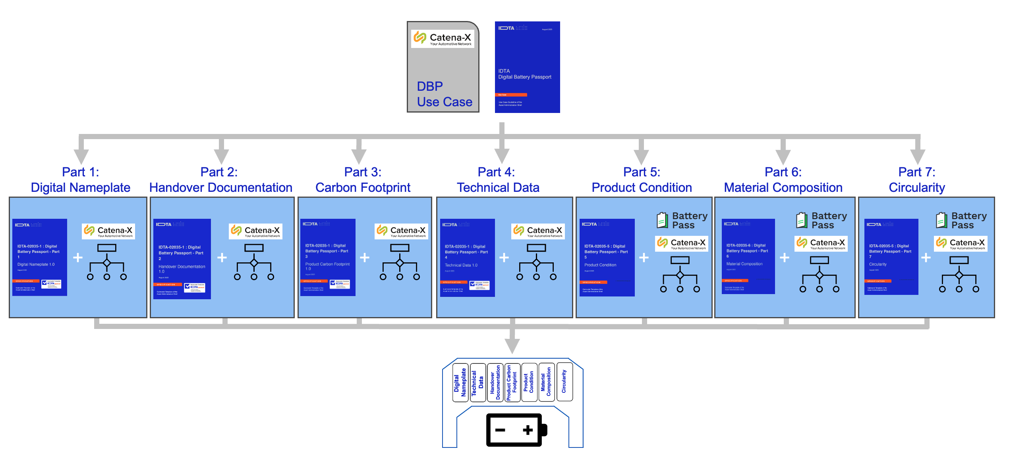
Figure 1: Conceptional overview of the design of the Digital Battery Passport based on the AAS

Overview of Digital Battery Passport as AAS

Overview
The following figure gives an example overview of an AAS that contains all submodels as specified in the parts 1 to 7. Such an AAS providing all required data information will fullfill the European Union regulatory requirements for batteries. The AAS can be provided as a file (also known as an AASX file) or offered via a standardized REST API for AAS [11].

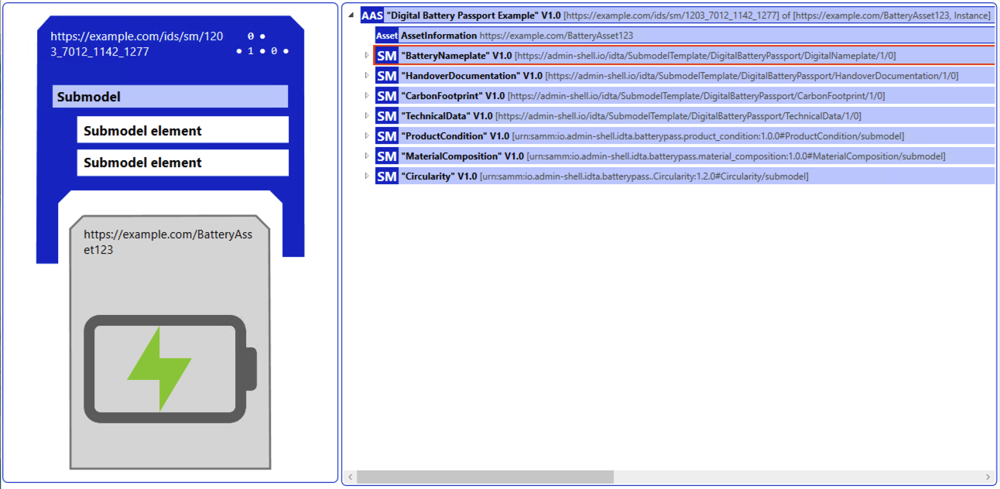
Figure 2: AAS example of a Digital Battery Passport with all submodels (screenshot from AASX Explorer)

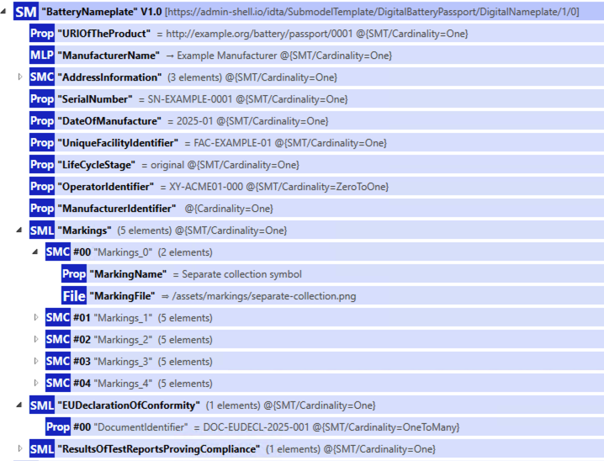
Figure 3: Sample instance of the BatteryNameplate submodel

The following subsections provide an overview of the submodel content. Specification details can be found in the relevant specification submodel template documents.

Digital Nameplate for the Digital Battery Passport
Specification details can be found in Digital Battery Passport - Part 1: Digital Nameplate 1.0 (IDTA-02035-1).
The Submodel template is derived from "Digital Nameplate for Industrial Equiqment 3.0 (IDTA-02006)" and extended with battery specific attributes as needed in DIN DKE SPEC 99100.
This submodel is mainly used to provide all Identifier-related information, e.g., of the battery and manufacturer.
The following figure gives an overview of the submodel template.
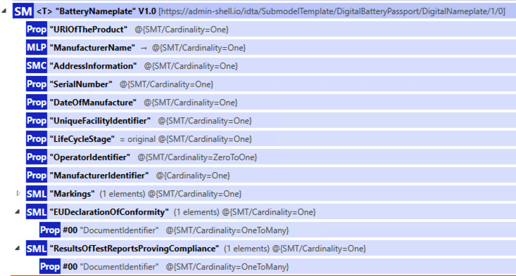
Figure 4: Overview submodel template Digital Battery Nameplate

Handover Documentation for the Digital Battery Passport
Specification details can be found in Digital Battery Passport - Part 2: Handover Documentation 1.0 (IDTA-02035-2).
The Submodel template is derived from the Submodel template "Handover Documentation 2.0 (IDTA-02004)" where some mandatory elements are not contained or decleard as optional.
This submodel is used to provide all relevant documents needed for the Digital Battery Passport.
The following figure gives an overview of the submodel.

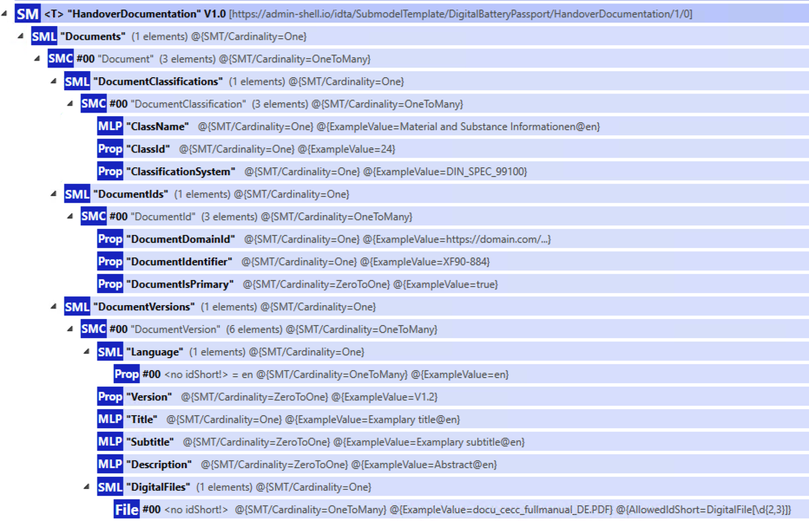
Figure 5: Overview submodel template Handover Documentation

Carbon Footprint for the Digital Battery Passport
Specification details can be found in Digital Battery Passport - Part 3: Product Carbon Footprint 1.0 (IDTA-02035-3).
The Submodel template is a subset of the Submodel template "Product Carbon Footprint 1.0 (IDTA-02023)". It is used to declared in terms of kg of carbon dioxide equivalent per one kWh of the total energy provided by the battery over its expected service life.
The following figure gives an overview of the submodel.
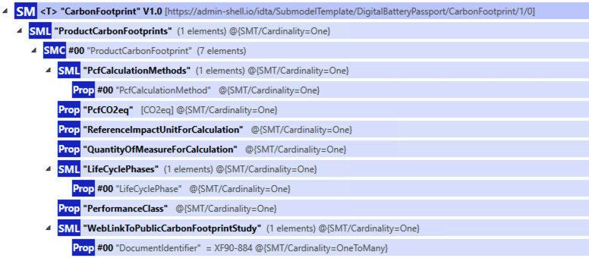
Figure 6: Overview submodel template Carbon Footprint

Technical Data for the Digital Battery Passport
Specification details can be found in Digital Battery Passport - Part 4: Technical Data 1.0 (IDTA-02035-4).
The submodel instance Technical Data is used to provide all static (model) technical based data attributes of a battery as decleated in the DIN DKE SPEC 99100, exceptions are carbon footprint, materials, and circularity (each have their own submodels, see next sections).
The following figure gives an overview of the submodel.

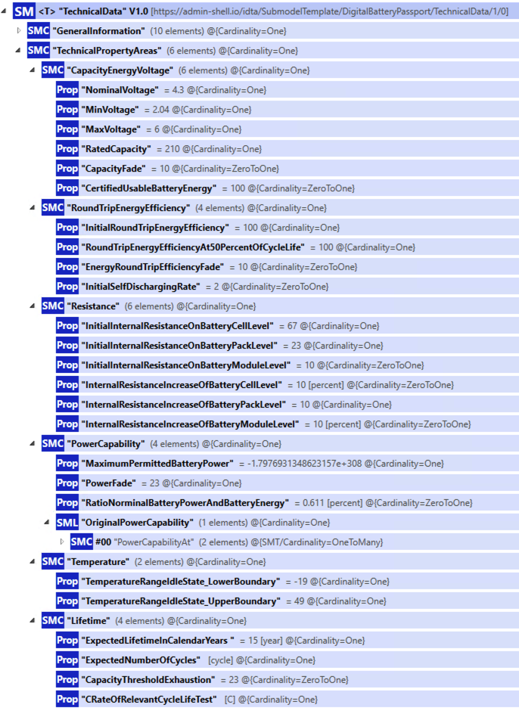
Figure 7: Overview submodel template Technical Data

Product Condition for the Digital Battery Passport
Specification details can be found in Digital Battery Passport - Part 5: Product Condition 1.0 (IDTA-02035-5).
This submodel is used to for all dynamic item attributes as specified in the DIN DKE SPEC 99100. Every dynamic attributes is modelled as a pair with value und updateDate.
The following figure gives an overview of the submodel.
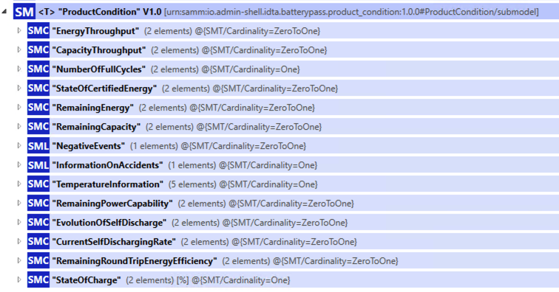
Figure 8: Overview submodel template Product Condition

Material Composition for the Digital Battery Passport
Specification details can be found in Digital Battery Passport - Part 6: Material Composition 1.0 (IDTA-02035-6).
This submodel is used to provide information of the material acquisition of the battery including harzardous substances based on DIN DKE SPEC 99100.
The following figure gives an overview of the submodel.

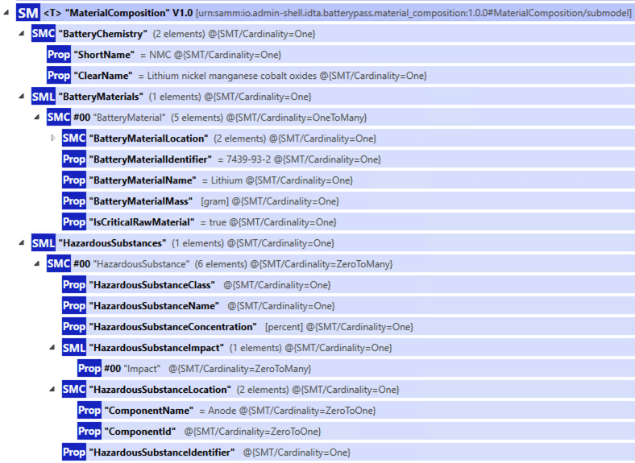
Figure 9: Overview submodel template Material Composition

Circularity for the Digital Battery Passport
Specification details can be found in Digital Battery Passport - Part 7: Circularity 1.0 (IDTA-02035-7).
This submodel is used to provide all circularity-based information based on the DIN DKE SPEC 99100.
The following figure gives an overview of the submodel.
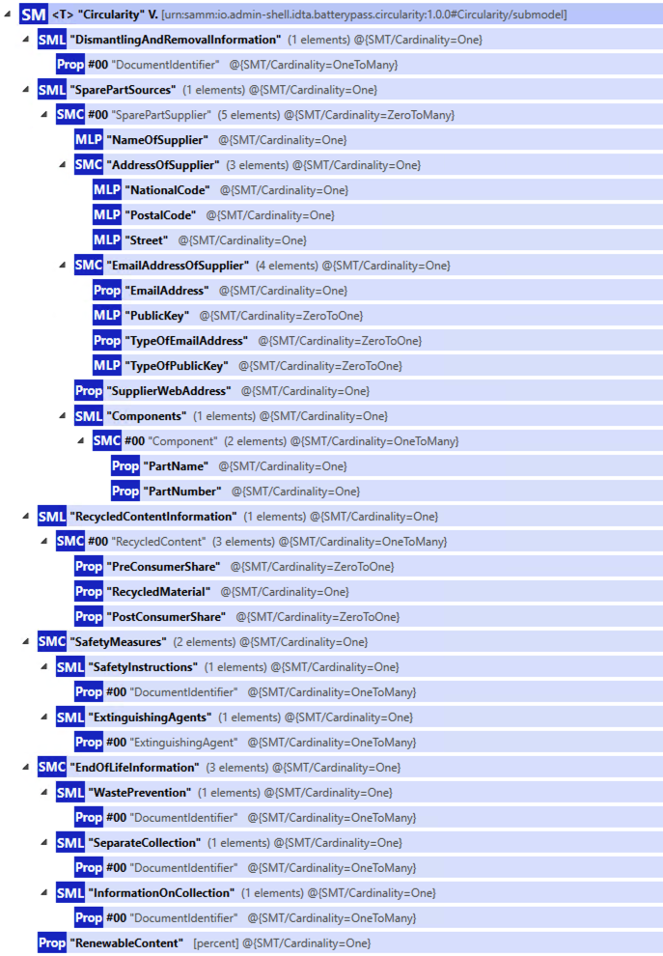
Figure 10: Overview submodel template Circularity

- Explanations on used table formats
- General
The used tables in this document try to outline information as concise as possible. They do not convey all information on Submodels and SubmodelElements. For this purpose, the definitive definitions are given by a separate file in form of an AASX file of the Submodel template and its elements.

- Tables on Submodels and SubmodelElements
For clarity and brevity, a set of rules is used for the tables for describing Submodels and SubmodelElements.
- The tables follow in principle the same conventions as in [5].
- The table heads abbreviate 'cardinality' with 'card'.
- The tables often place two informations in different rows of the same table cell. In this case, the first information is marked out by sharp brackets [] form the second information. A special case are the semanticIds, which are marked out by the format: (type)(local)[idType]value.
- The types of SubmodelElements are abbreviated:
SME type | SubmodelElement type
Property | Property
MLP | MultiLanguageProperty
Range | Range
File | File
Blob | Blob
Ref | ReferenceElement
Rel | RelationshipElement
SMC | SubmodelElementCollection
- If an idShort ends with '{00}', this indicates a suffix of the respective length (here: 2) of decimal digits, in order to make the idShort unique. A different idShort might be choosen, as long as it is unique in the parent’s context.
- The Keys of semanticId in the main section feature only idType and value, such as: [IRI]https://admin-shell.io/vdi/2770/1/0/DocumentId/Id. The attributes "type" and "local" (typically "ConceptDescription" and "(local)" or "GlobalReference" and (no-local)") need to be set accordingly; see [6].
- If a table does not contain a column with "parent" heading, all represented attributes share the same parent. This parent is denoted in the head of the table.
- Multi-language strings are represented by the text value, followed by '@'-character and the ISO 639 language code: example@EN.
- The [valueType] is only given for Properties.

Bibliography
[1] How to Create a Submodel Template Specification. V1.1. [Online] Available: https://industrialdigitaltwin.org/wp-content/uploads/2025/06/IDTA_How-to-write-a-SMT-v1.1.pdf)
[2] Semantic Aspect Meta Model. V2.2.0. [Online] Available: https://eclipse-esmf.github.io/samm-specification/2.2.0/index.html
[3] Submodel Templates. Publisher: IDTA. [Online] Available: https://github.com/admin-shell-io/submodel-templates
[4] Semantic Models. Publisher: IDTA. [Online] Available Semantic Models. https://github.com/admin-shell-io/smt-semantic-models
[5] Semantic Models. Publisher: Catena-X. [Online] Available: https://github.com/eclipse-tractusx/sldt-semantic-models
[6] Standards Catena-X. Publisher: Catena-X. [Online] Available: https://catenax-ev.github.io/docs/next/standards/overview
[7] Specifications Asset Administration Shell. Publisher: IDTA. Release 25-01. [Online] Available: https://industrialdigitaltwin.org/en/content-hub/aasspecifications
[8] Catena-X Governance Process for the Creation and Standardization of Semantic Models. V1.0. Publisher: Catena-X. [Online] Available: https://catenax-ev.github.io/modeling-governance
[9] DIN DKE SPEC 99100:2025-02. Requirements for data attributes of the battery passport. Release 2025-02. Available: https://www.dinmedia.de/de/technische-regel/din-dke-spec-99100/385692321
[10] Battery Pass project. Advancing the implementation of the battery passport in Europe and beyond. Webpage: https://thebatterypass.eu/
[11] IDTA 01002 Specification of the Asset Administration Shell. Part 2: Application Programming Interfaces, Version 3.1. Industrial Digital Twin Association (IDTA), January 2025. Online. Available: https://industrialdigitaltwin.io/aas-specifications/IDTA-01002/v3.1/index.html
[12] Catena-X. [Online] Available: https://catena-x.net

www.industrialdigitaltwin.org

